ITC 3154 Cognitive Computing
Professor Giannis Bartsiokas
Fall 2024
Ezra Odole – 280969
Angelous Michalopoulos – 266697
Due Date: December 11th, 2024

Cognitive Computing final project report
Abstract:
The problem that our group project addressed was a multi-class classification problem, trying to train an algorithm to be able to predict next year’s playoff outcomes of the NCAA March Madness tournament. The target variable of the project was the postseason feature which was separated in 8 classes, all depicting how far in the tournament a team would go (champions, 2nd, F4, E8, S16, R32, R64, R68). The dataset the group used in order to train the algorithm is the college basketball dataset from Kaggle (https://www.kaggle.com/datasets/andrewsundberg/college-basketball-dataset ), which contains the team stats of all college basketball teams from 2013 until 2024 in separate datasets (the 2020 and 2024 datasets don’t have the postseason feature because for the 2020 season the tournament did not happen because of the covid-19 pandemic and for the 2024 season the dataset has not been updated for the results of the dataset yet). It also contains a combined dataset for the seasons 2013-19 and 2021-23 where it has all the same features as the individual season datasets plus the year feature to show which years each teams’ stats correspond to (as well as what round they finished in the tournament and their respective seed). For the project we used the combined data set as it is all the historical information we need in order to complete the problem that we have chosen to work on. The key finding of the problem was that with multi-class problems (especially those with class imbalance like our dataset) the accuracy is going to be very low (struggling to reach even 50%), even with hyperparameter tuning, because it can predict the first round of the tournament since more teams end the tournament run during the first round, but for the last rounds, such as F4 and onwards, since there are not a lot of teams (10 for champions and 2nd, and 20 for F4) the algorithms and the models can struggle. The above is also evident from the fact that the best overall performance of the models was the decision tree algorithm with an accuracy of (0.4411764705882353).

Introduction:
March Madness is one of the most popular sporting events in the United States and basketball in general. The tournament not only generates significant economic impact (Hermon) but also cultural impact since it attracts millions of viewers (The Daily Iowan) and has created a tradition of trying to predict the perfect bracket (even some presidents of the United States have released their perfect bracket prediction on the NCAA social media). Predicting the outcomes of the NCAA tournament creates a unique challenge due to the fact that the format of the tournament is single elimination, which means that outliers (teams that have a lower seed) can actually advance further into the tournament (also known as Cinderella stories) making it harder to actually predict the final outcome of the tournament. Furthermore, the fact that each season has 64 teams (68 teams qualify and there is the “first four round” in which the 8 worst ranked teams compete for the final four spots in the first round) making it even harder to predict the outcome. Having all of these in mind, accurately forecasting playoff outcomes can provide valuable insights for analysts, coaches, and even fans creating tournament brackets. Moreover, the ability to predict success in such a competitive and unpredictable environment demonstrates the potential of machine learning models in handling real-world multi-class classification problems, especially those with imbalanced classes.
The dataset we have used, as mentioned above, is the college basketball dataset from Kaggle (https://www.kaggle.com/datasets/andrewsundberg/college-basketball-dataset) which combines almost all of the last 12 seasons of college basketball (except the 2020 and 2024 seasons, for the reasons mentioned above). The source of the dataset is from the website http://barttorvik.com/trank.php#., the creator of the Kaggle dataset retrieved all the stats from this website and then added the SEED, POSTSEASON and YEAR features for extra clarity and information. The size of the dataset we used (the main dataset with most of the seasons combined) is 3,523 rows (368 unique rows) and 24 columns (features). The key attributes of the dataset are:
Team Information:
TEAM: Name of the team.
CONF: Conference the team belongs to.
Performance Metrics:
G: Number of games played.
W: Number of wins.
Advanced Stats Metrics:
ADJOE: Adjusted Offensive Efficiency (points scored per 100 possessions, adjusted for opponent strength).
ADJDE: Adjusted Defensive Efficiency (points allowed per 100 possessions, adjusted for opponent strength).
BARTHAG: A power rating that predicts a team's chances of winning against an average team on a neutral court.
ADJ_T: Adjusted Tempo (pace of play, possessions per 40 minutes).
WAB: Wins Above Bubble (performance relative to teams on the tournament bubble).
Shooting Statistics:
EFG_O: Effective Field Goal Percentage (Offense).
EFG_D: Effective Field Goal Percentage (Defense).
2P_O / 2P_D: Two-point shooting percentage (Offense/Defense).
3P_O / 3P_D: Three-point shooting percentage (Offense/Defense).
Rebounding Metrics:
ORB: Offensive Rebound Percentage.
DRB: Defensive Rebound Percentage.
Turnover and Free Throw Rates:
TOR: Turnover percentage (Offense).
TORD: Turnover percentage (Defense).
FTR: Free Throw Rate (Offense).
FTRD: Free Throw Rate (Defense).

Postseason Data:
POSTSEASON: Indicates postseason performance (e.g., tournament progress, null for non-tournament teams).
SEED: NCAA Tournament seed (null for non-tournament teams).
Temporal Information:
YEAR: The year of the season.
The main objective of the dataset was to create a machine learning algorithm that is able of accurately predict how far a team can go in the NCAA March Madness tournament based on the historical and season performance data of the teams. The way we proceeded was by exploring and pre-processing the dataset to address missing values and class imbalances as well as selecting and tuning machine learning algorithms suitable for multi-class classification.
Finally, the real-world application of this problem and its solutions is that accurately predicting playoff outcomes in NCAA March Madness can influence and help in many practical issues such as in Bracketology, helping fans and analysts build more accurate tournament brackets. It can help in sports analytics by assisting teams and coaches in identifying critical performance metrics to focus on for their success. The most obvious way this algorithm helps is with betting and forecasting by helping betting companies and sports analysts in developing predictive tools.

Exploratory Data Analysis (EDA) and Data Cleaning:

Exploratory Data Analysis (EDA) and data cleaning are critical steps in understanding the structure, trends, and potential challenges within the dataset before building predictive models. Starting with the EDA part of the project the first thing we did was to depict the correlation of all the features with predictive capabilities, which were all the features except the team’s name and conference features as they are not important for the final outcome. For the postseason feature which was a categorical feature we encoded it using the map function in order to turned it into a numerical feature.
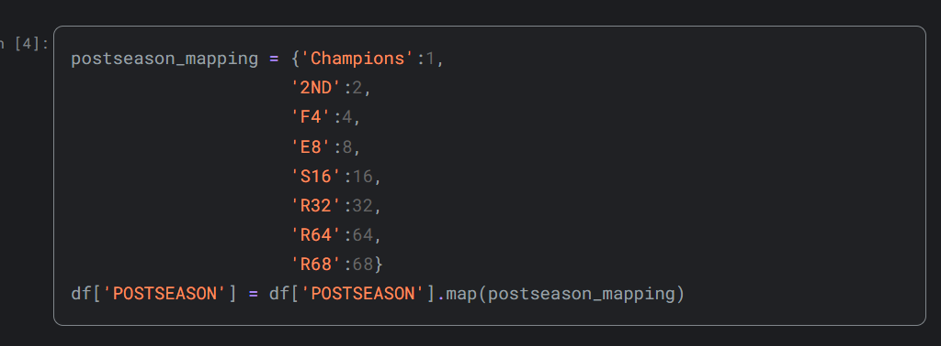
With the new numerical features, we then created a correlation table depicting the correlation of each feature with each feature so that we can have a clear depiction on which features where the most important for the target variable (the postseason).
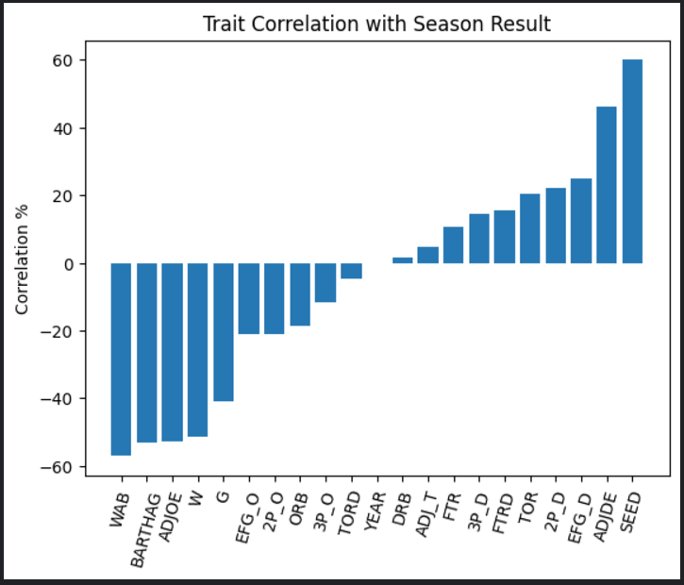
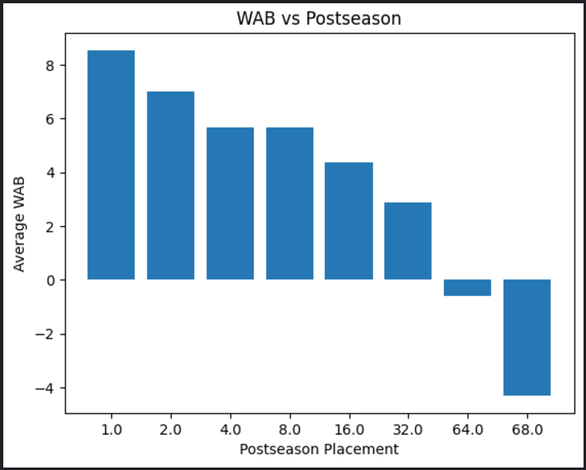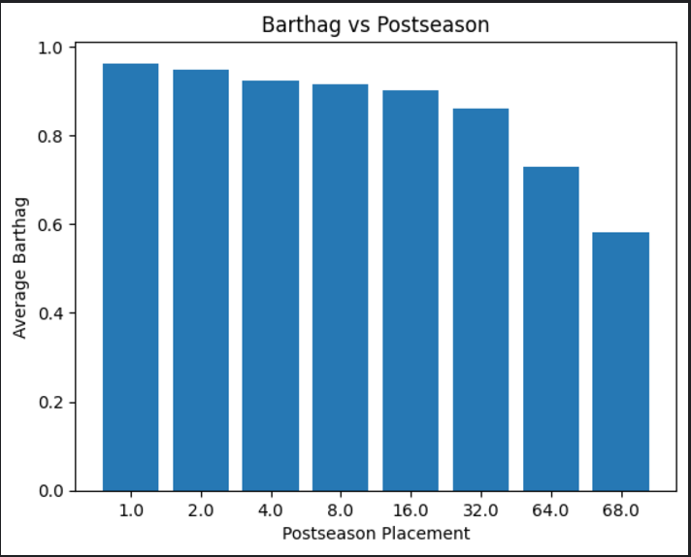
Following, we ranked the most important features based on the seed feature which theoretically was the most important feature for postseason as higher seed (smaller number) means stronger team. The next thing we did in order to have a better understanding of the dataset is that we provided the mean, median and the standard deviation of each feature.
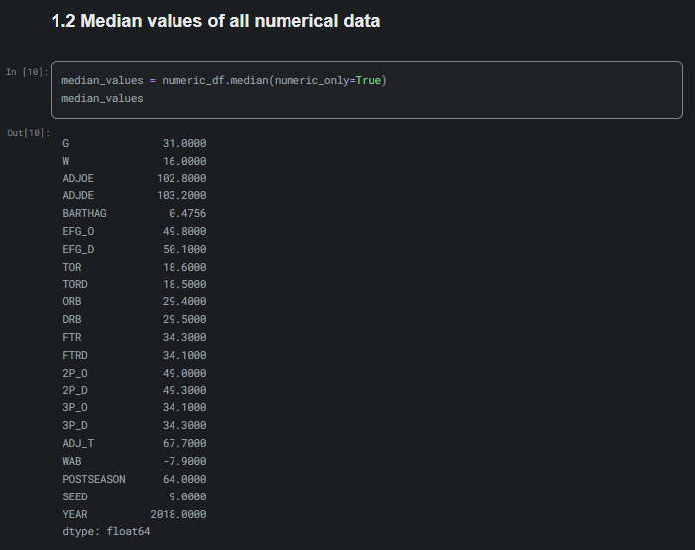
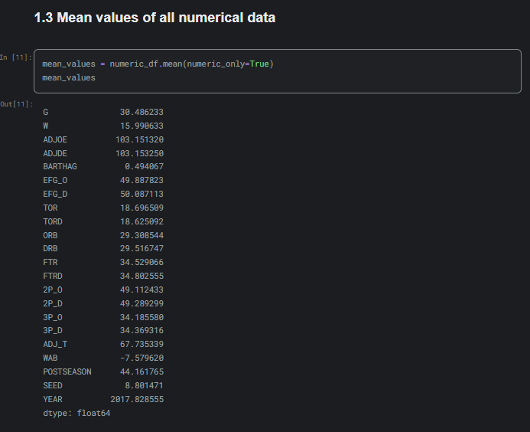
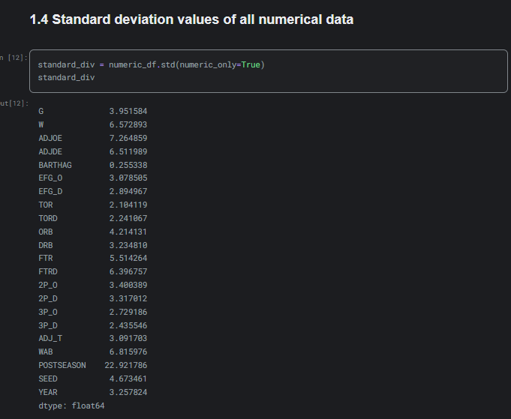

Using these tables we can see that most teams attributes such as games, wins and shooting percentages are average, by the fact that the median and the mean are about the same and by the fact that the standard deviation for most of the attributes is small. But there are cases like in the wins feature were the standard division is big (6.6) showing big disparity with the good teams and the bad teams (makes sense, good teams win more than bad teams). To have a better understanding, especially for how the features affect the postseason feature, we grouped them and used the describe function to show count, mean, std, min, 25%, 50%, 75%, max. With this technique we can see how each class in the postseason feature is spread compared to another feature, for example the wins and seed features.
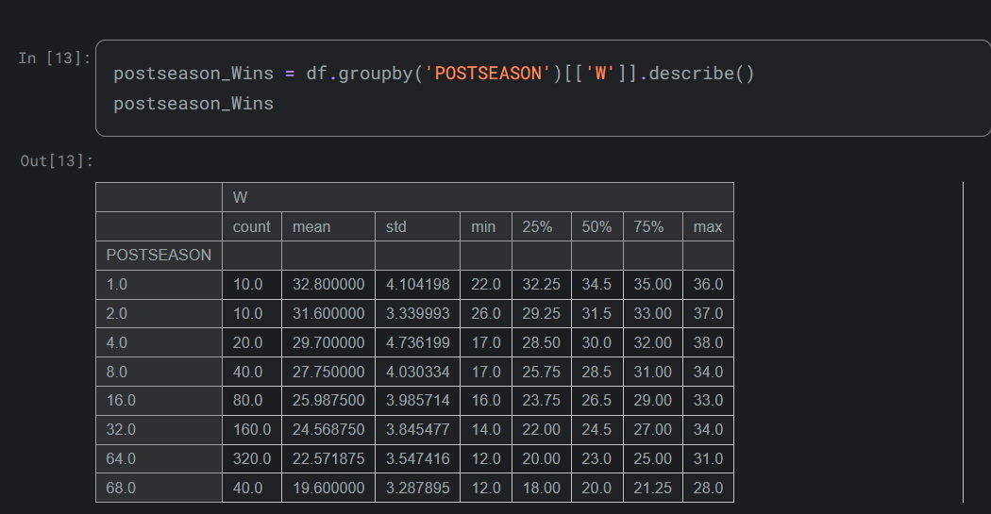

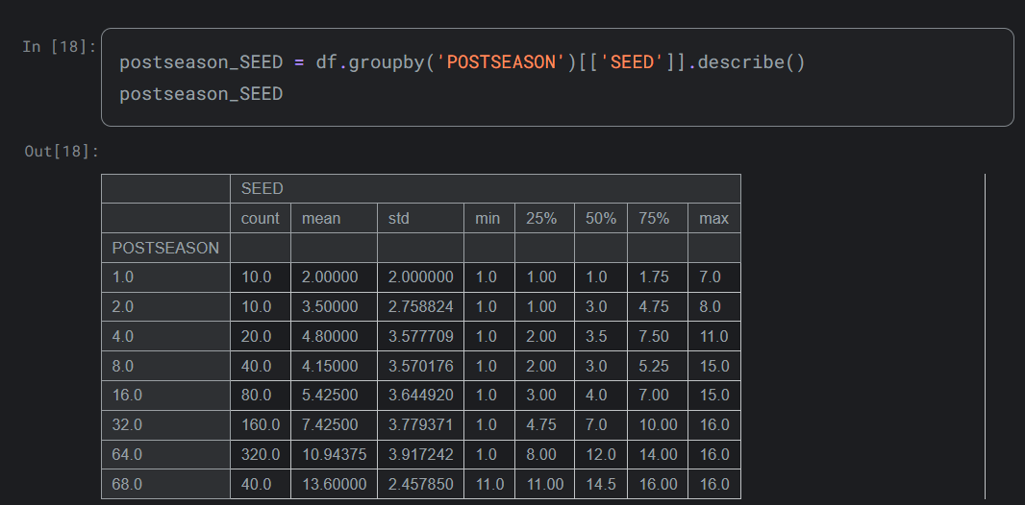

From the screen shots we can see the descripted statistics for the grouped data. For Postseason Wins we see that higher postseason stages (e.g., 1.0, 2.0, 4.0) correspond to teams with significantly higher average wins (e.g., 32.8 for 1.0, 31.6 for 2.0). We also see that the standard deviation decreases as postseason levels increase, suggesting more consistent team performance at higher levels. The median wins for levels such as 32, 64, and 68 however remain around the low 20s, indicating weaker overall performance.
For the Postseason Seeds grouping we can see that lower seed numbers (e.g., mean 2.0 for postseason 1.0) correspond to better-performing teams at the highest levels, as expected since lower seeding number means stronger team. We can also see the variance in seed numbers increases for levels such as 16, 32, and 64, showing a wider range of team quality in earlier postseason rounds. Postseason 68.0 corresponds to higher seed numbers (mean 13.6), reflecting weaker teams that barely made it to the tournament. We also see that for all the stages from R64 and onwards (the tournament stages) the minimum seed is 1 depicting that at least 1 number 1 seed has lost in each round. We can also see this type of outliers in the max categories where even as high as postseason 1.0 (champions) a 7th seed has won and an 11th seed has reached the F4, meaning that while this types of outliers does not happen all the time, since the mean is low for the higher rounds, they do however happen and even a high seed doesn’t guarantee advancement to the next stage of the tournament.
The next thing we did for the project was the data cleaning. Since the data was already clean when we downloaded it from Kaggle we used some techniques so that we can make sure that it was indeed cleaned. These techniques were identifying the number of null values of each feature, the unique values, the duplicate rows, and the variance of each feature. Firstly using the df.isnull().sum() function we can see that the only features with null values are the seed and postseason features. This was not a problem since those null values are the non-tournament teams so they have a null value for both features.
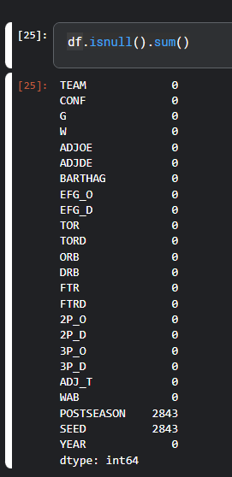
The second thing we did for the data cleaning process what to drop any features that have a low percentage of unique values, if that percentage is not justified.
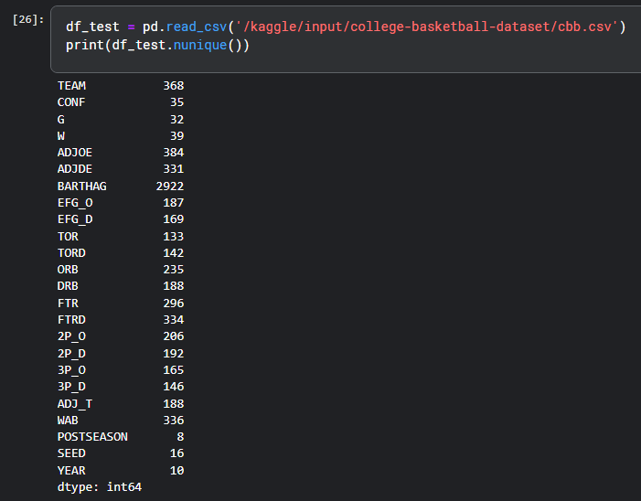
As we can see form the output of the code the only features that have a low unique value percentage are the team, conference, postseason, seed and year features. For these features it makes sense that they would have low number of unique values since there is a set number of teams and conferences and since the dataset spans 10 years, the same teams and conferences are bound to appear multiple times. For the rest of the features, they are numerical values with a set number of options for example the seed feature spans from 16-1 so again it makes sense that there won’t be a big number of unique values. Moving on we identified the duplicate rows of the dataset which were none. The last thing we did was check the variance of each feature and again found that the dataset did not have a problem with the variance.
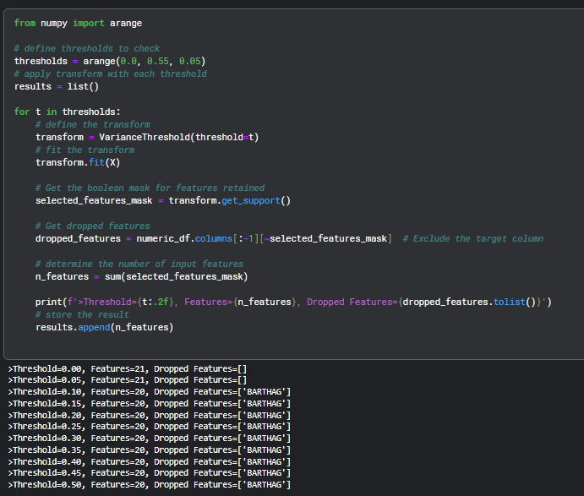
The only feature the output suggests that we drop is the BARTHAG feature, but that feature is important for the final prediction of the problem. And since the feature depicts the chances of beating an average d1 team it makes sense that it has a low variance.
The EDA and data cleaning process significantly influenced data pre-processing and model selection. Correlation analysis highlighted key features like seed and wins, guiding the exclusion of irrelevant features such as team names and conferences and year.
Model Selection and Training:

For the project the models that we selected where SVM, Decision trees and FFNNs in order to predict the NCAA tournament outcomes. The rational for selecting the SVM and the decision tree models is noted below. Firstly, the SVM was selected for its ability to handle high-dimensional data and to find optimal decision boundaries, which is very important for multi-class classification problems. The Decision tree models were chosen for their ability to handle non-linear relationships and interpretability. Furthermore, one more reason for selecting them was their ability to understand how features like seed and wins influence predictions. These reasons are also very important for classification problems with multiple classes.
In order to train the models, we had to split the dataset to train and test datasets. Using the following code:
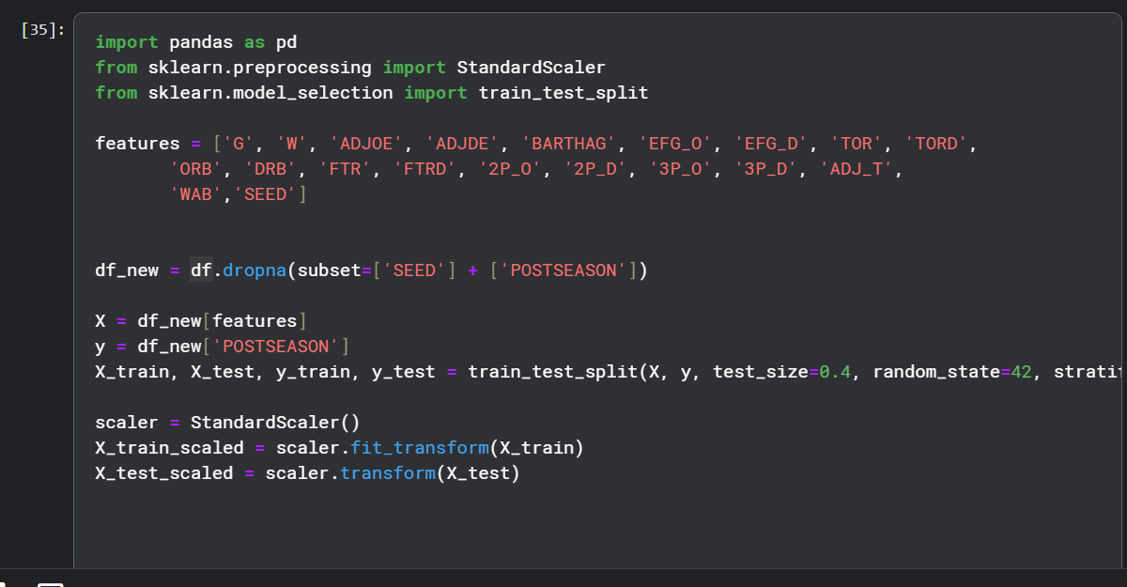
In the code, we identify the feature that we want to predict (POSTSEASON) and the features that we will use in order to make that prediction. We then make a new df called df_new that uses only the rows that don’t have null values and we split the new dataset to train and test datasets. Originally we had a 80/20 split but that created a lot of problems with the results of the models (usually that only one class was predicted and the others had 0 accuracy 0 precision, 0 F1 score and 0 recall) because the test dataset didn’t have a lot of cases of the smaller classes, so to fix that problem we split it with 60/40 ratio. For the SVM model we also scaled the data because the model is sensitive to the scale of input feature.
The initial result of the SVM and the Decision tree algorithms have an accuracy of 0.4889705882352941 and 0.4411764705882353 both of which while low are good accuracy for this type of problem. However, while conducting a deeper analysis on the results we can see some problems with the final result of the performance of both models (especially the SVM model).
SVM:
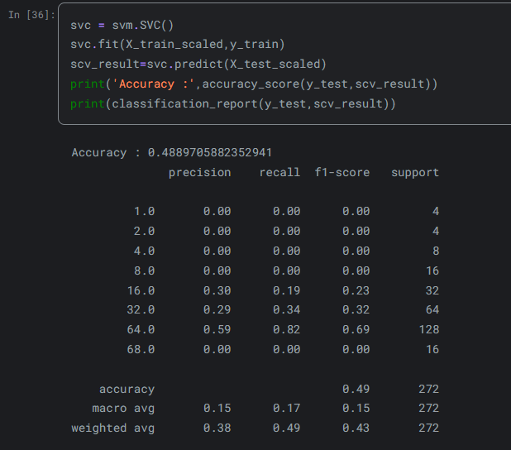
Starting with the SVM model we see that while it has a high final accuracy that accuracy is misleading since most classes don’t even attempt a prediction and have an accuracy of zero, and because the accuracy of the postseason 64.0 class is high it makes the final accuracy seem a lot better. The main result from this analysis is that we see that the model struggles with class imbalance, for example the precision of the model varies significantly across the classes having a precision of 0.59 in a highly represented class as 64.0 but for classes like 1.0 and 2.0, which are underrepresented, is has a precision of 0.00. Since precision represents the amount of the models positive predictions that were correct this shows a class bias towards the majority class (64.0). This can also be seen in both the weighted avg and the macro avg which are both low, the macro avg precision (which represents the classes all with equal weight and can give us a better view of how model performed across all classes) is a very low number (0.15) and the weighted avg (which accounts for class sizes, providing a realistic view of overall performance in imbalanced datasets, where majority classes dominate by giving more support to classes with more samples) is again low (0.38). The Recall of the SVM model (which measures how many of the positive cases where correctly identified by the model) also shows that the class struggles with class imbalance by having the recall of the majority class (64.0) be very high at 0.82 but once again class like 1.0,2.0 and 4.0 have a recall of 0.00. Similarly with the precision, the macro avg is again very low (0.17) and the weighted avg (0.49) aligns more closely with the majority class and misses underrepresented ones. When it comes to the F1, which shows a balance between precision and recall, making it the most useful metric for imbalanced datasets, we see the same trend as with the other to metrics of the model, high F1 score in the majority class and zero in the most underrepresented class and just like the other metric we get the same result when looking at the macro and weighted avg once again showing the model’s struggle with class imbalance.

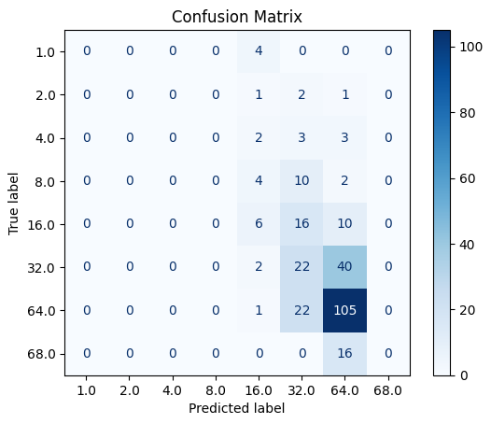

Decision Tree:
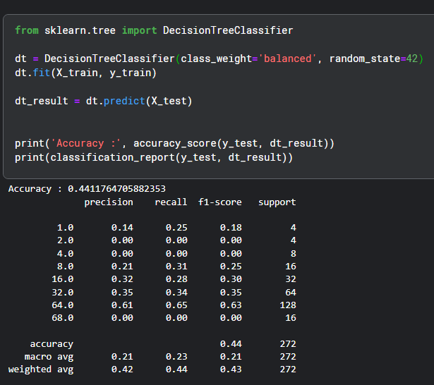
When looking at the Decision Tree model, while it does have a lower overall accuracy that the SVM model it has performed better since it has made predictions for most of the classes (it has not made predictions for class 2.0 and 4.0) and has higher macro avg in all the metrics and higher weighted avg for the precision and very close for the F1.
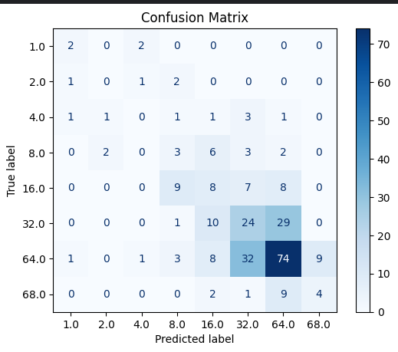
Feed Forward Neural Network:
The final machine learning method we used was a Feed Forward Neural Network. We believe this is a useful method because of the robustness of Neural Networks. Our Dataset has 20 variables that we aim to correlate with the dependent variable making it a highly complex problem. Neural Networks are perfect in that regard because they are built to handle high-variable inputs and give reliable results.
The train test split used for the Neural network was an 80/20 train-test split. The initial performance of the algorithm was poor with the loss beginning to level off at 1.3. We were seeing an accuracy of only 16% (22 out of 136 correct) on initial runs. But as discussed previously, while the model has 600 individual team outcomes to test and train on, there was only 10 seasons of data, meaning for outcomes like the winning team or the semi-finals there were only 10 datapoints in total and the testing data only had 2 data points. We thought this lack of robustness for the niche outcomes has contributed to the poor accuracy. But eventually with parameter tuning we were able to get far better results. We landed on 2 hidden layers with 20 nodes each, with a learning rate of 0.01. With that we had a 49% accuracy, below are the other calculated values.
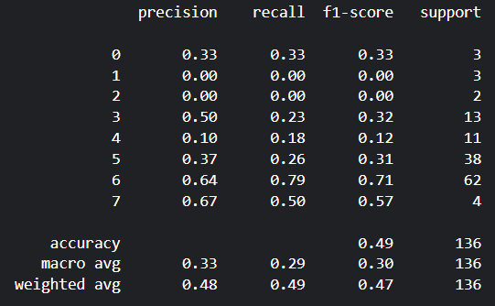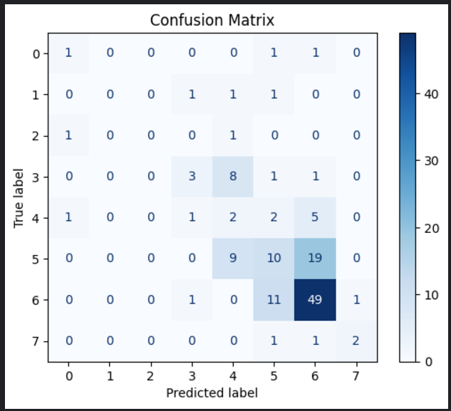
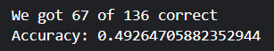
As seen with the confusion matrix, our Neural Network is once again using the class imbalance to its favour to achieve a higher accuracy. Unlike the SVM though, there were multiple attempts at predicting the higher postseason placements.
Hyperparameter Tuning:
The hyperparameters that are tuned are for SVM are C and gamma. The parameter C determines the balance between minimizing classification error and maximizing the margins between classes. The smaller the C gets the higher the priority in maximizing the margin between the classes, while the larger the C gets the priority is in correctly classifying the training data. The parameter gamma defines the influence of the individual data points. The smaller gamma value becomes, the more each data point's influence extends, resulting in a smoother decision boundary. A larger gamma value focuses on fitting the training data more tightly but that can lead to overfitting. For the decision tree algorithm, the hyperparameters are criterion, max_depth, min_samples_split, min_samples_leaf. The criterion parameter defines the function used to measure the quality of splits. In addition, max_depth controls the maximum depth of the algorithm which can prevent overfitting by preventing overly specific splits. Furthermore, min_samples_split specifies the minimum number of samples required to split internal nodes and min_samples_leaf specifies the minimum number of samples that are required to become leaf nodes.
The tuning method used for the SVM, and Decision tree models is the Grid Search. We used a systematic approach to test all the combinations of the hyperparameter values mentioned above for both models. We also used a 5-fold cross validation to ensure that the results were reliable and not specific to a particular train-test split.
From the grid search hyperparameter tuning the best parameters that we got where Best Parameters: {'C': 100, 'gamma': 'scale'} and for the SVM model Best Parameters: {'criterion': 'gini', 'max_depth': None, 'min_samples_leaf': 2, 'min_samples_split': 2} for the decision tree model.
The effect of the new hyperparameters in the SVM model are, for C=100 the larger number increases the models ability to classify points correctly, which helps for the underrepresented classes, for 'gamma' = ‘scale’ it ensured smoother decision boundaries that generalize well, preventing overfitting to noise. For the decision tree model The ‘criterion’ = ‘gini’ parameter ensures that splits minimize impurity effectively, capturing meaningful splits while avoiding unnecessary complexity. At the same time, max_depth=None helps the tree to fully explore all the possible patterns. The min_samples_leaf=2 and min_samples_split=2 parameters prevent overly specific splits, helping improve generalization and reducing noise sensitivity.
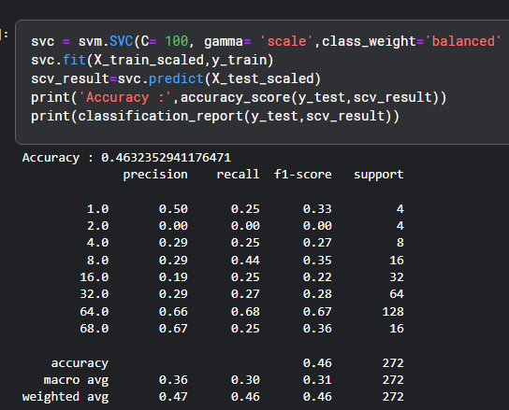
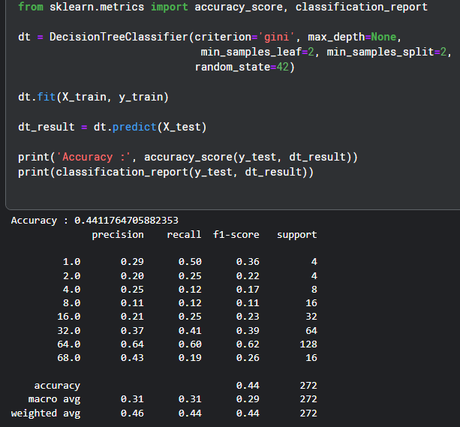

For both models the grid search versions perform better that the default parameters versions.
For the SVM models the grid search version performed better in almost every metric (for the macro avg), except final accuracy which is slightly worse, but the new model has made predictions for more classes which means that while it has a worst accuracy its predict more classes. For the weighted avg the original SVM model has a better recall but that is because of the better overall final accuracy and not a sign that it has performed better.
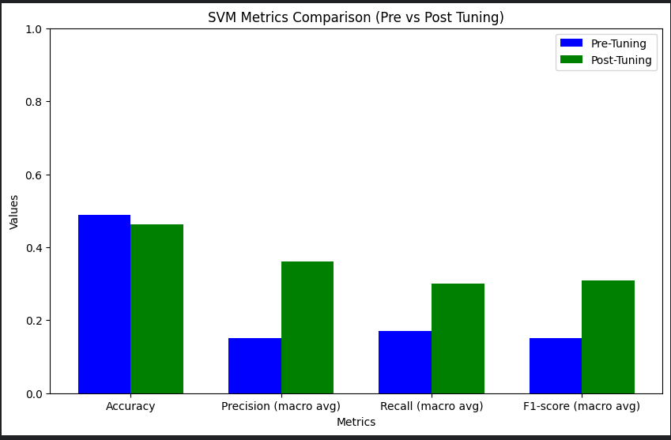
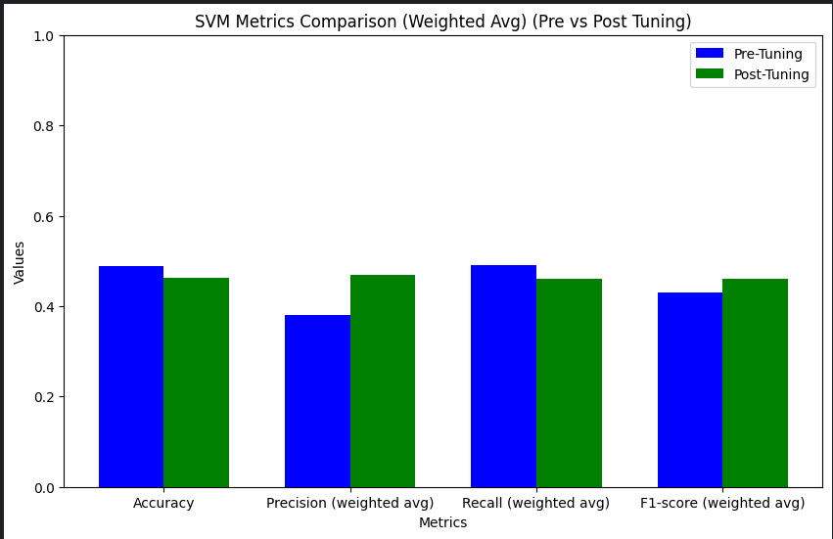
For the Decision tree model the final accuracy stays the same but the macro avg for all the other metrics perform better and the same applies for the weighted avg (with the exception of the recall that is the same in both version).
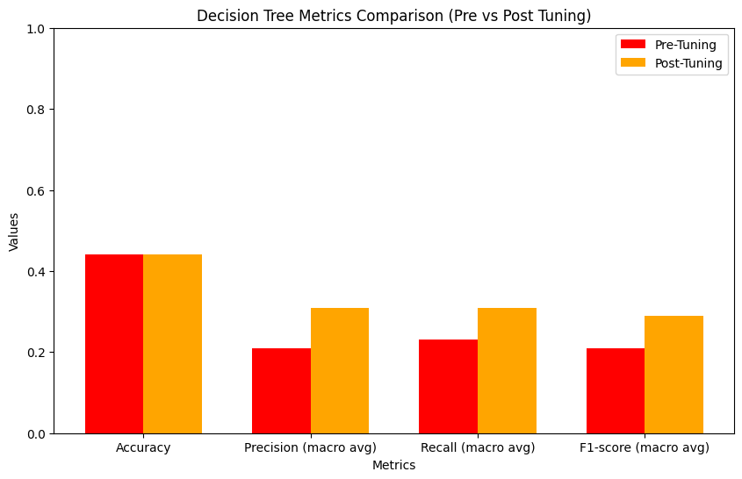
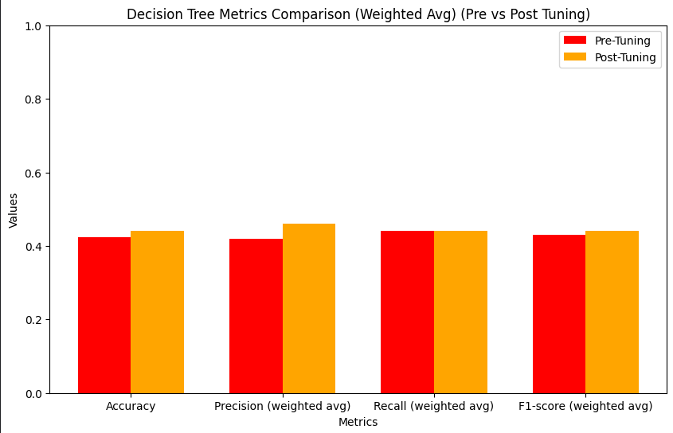

For the Neural Networks, grid search hyperparameter tuning was also used, with interesting results. The parameters tuned for the neural networks were the number of hidden layers, learning rate, and the number of hidden layer nodes. We used 2 and 3 hidden layers; 20, 50, and 100 nodes; 0.005, 0.01, 0.03, and 0.05 for the learning rate. Through the 24 combinations we found that 2 hidden layers with 20 nodes each and a learning rate of 0.01 ended up being the best combination with a loss value of 0.1271 after 1000 epochs. Shown below is the loss graphed over the number of epochs. For the visualization we shortened the training time from 1000 epochs to 200, to better show the plateau that occurs around the 100th epoch.
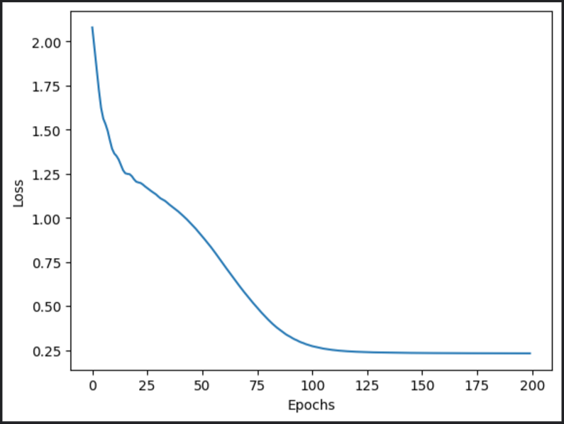
This shape of the training graph remained relatively consistent, the only differences being when the plateau would occur, and at what loss. The increase of hidden nodes usually lead to a higher final loss, regardless of other factors. For example, on two hidden layers, when going from 20 to 50 nodes we saw a 0.1 increase in the final loss value, and from 50 to 100 nodes we saw a 0.4 increase in the final loss.
With the higher learning rates (0.3 and 0.5), we saw an instability in the loss over the course of the model’s training. Often with a higher loss there would be a sudden spike in the loss after a few hundred epochs, eventually coming back down but never dropping below the previous plateau.
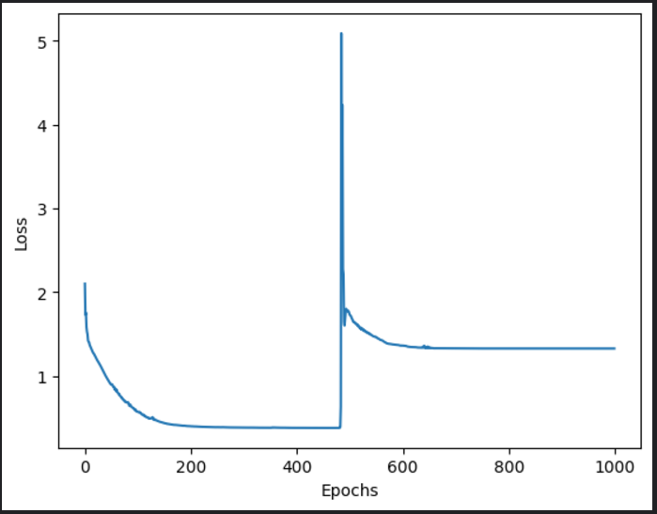
When switching from 2 to 3 hidden layers, we saw an increased number of those sudden spikes, even with the lower learning rates. This points to the idea that the model is not gaining anything from a more complex structure, and that our problem is able to be modelled well with only 2 hidden layers.
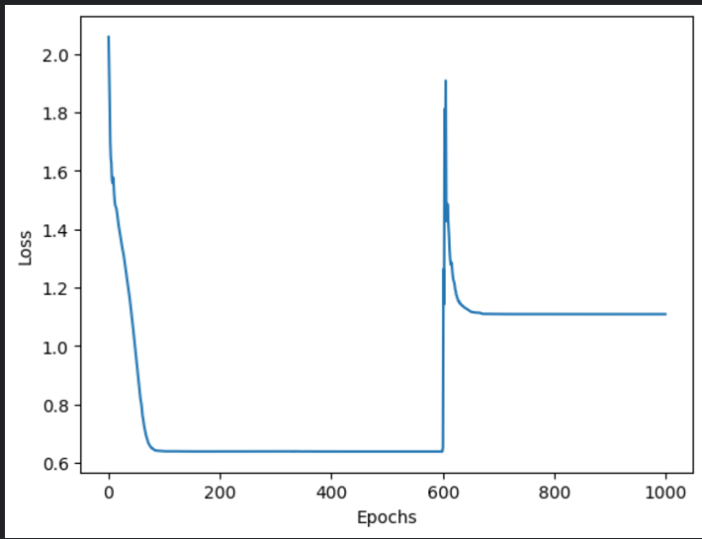

Discussion and Insights:
In our project we aimed to create an algorithm that would be able to predict the outcomes of NCAA March Madness tournaments based on a number of basic and advanced statistics and metrics such as the Adjusted Offensive Efficiency or the Barthag which is the power rating to predict a team’s chances of winning against the average team. The variable we were predicting was the postseason feature, which signifies a team’s final bracket placement.
We employed three algorithms to try and model the postseason feature, those being a Support Vector Machine, a Decision Tree, and a Feed Forward Neural Network. After cleaning the data and training our models, we found a couple of things.
The best model was the Neural Network, with an accuracy of 49%, followed by the SVM with an accuracy of 48% and finally the decision tree of 44%. While these accuracy levels are high, they are somewhat misleading. Because of the nature of a bracket tournament, just under half of all of the test datapoints are in the 64th bracket class. If the models were to just guess the 64th class every time they would have similar accuracies. This class imbalance seems to be heavily influencing our algorithm’s training. As shown in the confusion matrix for the SVM, we see exactly that. There were many correctly guessed 64th round predictions, but beyond that there were progressively fewer and fewer correctly guessed classes, the higher classes (8th, 4th 2nd and 1st) had no predictions at all. The model did not try to predict them. The highest label the model would predict was the 16th round. This pattern continued further with the remaining models. The decision tree did slightly better, making some attempts at higher placement predictions, but it was making a substantial number of incorrect guesses across the board. And the Neural Network was having the same issue, while having multiple completely wrong guesses.
A strength of our approach was the use of multiple different models as opposed to relying on one single model. With the varied models we were able to get a larger base of predictions and see different prediction methods and their strengths. For example, the SVM was clearly relying on the class imbalance to achieve a higher accuracy while the decision tree was taking more risks in its predictions even though it was making some mistakes.
One of the biggest limitations of our modelling was the dataset’s missing values and class imbalance. Although the data was thorough and required little to no cleaning, there were only 10 fully filled out seasons, which made it difficult to accurately train our models when certain classes such as 1st and 2nd place only had 10 values. There were dozens of other seasons, but many of them did not come with the postseason stat. This meant that we had plenty of datapoints, but few of them contained our dependent variable making all of those seasons useless in terms of training.
Although it would’ve been possible to manually find and fill in the missing postseason values, that would have gone beyond the timeframe and scope of the project. If there was an opportunity to continue with this project that would certainly be an area to investigate, in order to have more data to train with. One possible solution to our class problem would be to randomly remove lower classes to balance out the dataset. For example randomly removing a portion of the 64th round postseasons, making it harder for the models to rely on that overwhelming class imbalance.
With this project it would be possible to become sports betting millionaires. In all seriousness, this is a sports analysis project which is a highly sought after subject, with teams, players, and fans all having some use for the field.

References:
Yadav, Amit. “Grid Search for Decision Tree.” Medium, Biased-Algorithms, 19 Nov. 2024, medium.com/biased-algorithms/grid-search-for-decision-tree-ababbfb89833.

Comment, et al. “SVM Hyperparameter Tuning Using GRIDSEARCHCV: ML.” GeeksforGeeks, 11 Jan. 2023, www.geeksforgeeks.org/svm-hyperparameter-tuning-using-gridsearchcv-ml/.

Hermon, Troy. “March Madness: A Slam Dunk for the US Economy.” Dodds Wealth Advisors, 21 Mar. 2024, www.doddswealthadvisors.com/blog/march-madness-a-slam-dunk-for-the-us-economy#:~:text=One%20of%20the%20most%20significant,a%2030%2Dsecond%20commercial%20slot.

“March Madness: A Cultural Phenomenon beyond the Court.” The Daily Iowan, dailyiowan.com/2024/01/09/march-madness-a-cultural-phenomenon-beyond-the-court/#:~:text=Conclusion,far%20beyond%20the%20final%20buzzer. Accessed 11 Dec. 2024.

Sundberg, Andrew. “College Basketball Dataset.” Kaggle, 18 Mar. 2024, www.kaggle.com/datasets/andrewsundberg/college-basketball-dataset.
Yadav, Amit. “Grid Search for Decision Tree.” Medium, Biased-Algorithms, 19 Nov. 2024, medium.com/biased-algorithms/grid-search-for-decision-tree-ababbfb89833.

Appendix:
https://www.kaggle.com/code/angelosmichalopoulos/final-project/edit/run/211028773#4.3-compering-hyperparameters
source of the dataset: http://barttorvik.com/trank.php#.

